n\

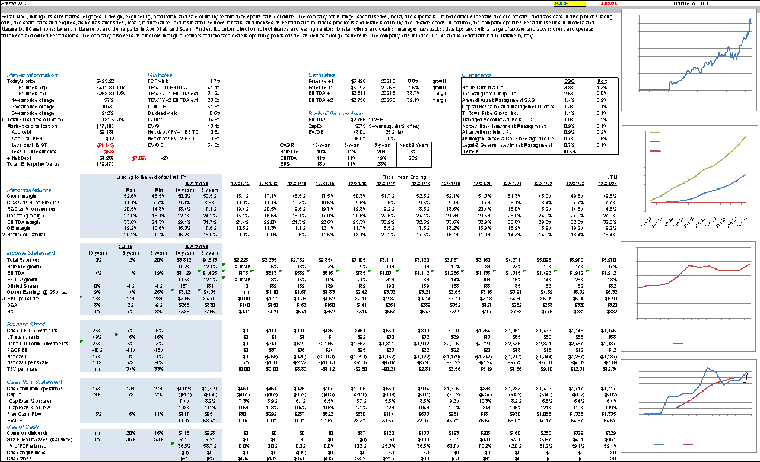

**BUSINESS SUMMARY**

**Business Description** – Ferrari ranks among one of the world’s top luxury brands, renowned for crafting, engineering, and selling luxury performance sports cars. Symbolizing exclusivity, innovation, and Italian design heritage, the brand is closely associated with Scuderia Ferrari, one of the most successful teams in Formula 1 history. They have had an impressive track record of over 1,000 Grand Prix races, 243 wins, and 16 Constructors’ titles. Operating from Maranello, Italy, Ferrari sells its cars in over 52 markets through 178 authorized dealers.

**Numbers and Segments/ Geography** **:**

| **Models / Shipment** | **2021** | **2022** | **2023** |
| --- | --- | --- | --- |
| **Range** | 93% | 96% | 97% |
| **Special Series** | 6% | 1% | 2% |
| **Icona Series** | 1% | 3% | 1% |

In 2021, ICEs dominated the shipments with 85% of the total, while hybrid engines accounted for 15%. The following year, 2022, shows a change in this distribution with ICEs decreasing to 78% and hybrid engines increasing to 22%. The trend of increasing hybrid engine shipments continued into 2023, where they constituted 44% of the total shipments, nearly half, while ICEs decreased further to represent 56% of shipments. This trend indicates a significant **shift towards hybrid engines** over the period shown, suggesting a strategic pivot or market demand inclining towards more hybrid technology in the units shipped.

The following chart shows the percentage of our unit shipments by geographic market for the years ended December 31, 2021, 202, and 2023 respectively:

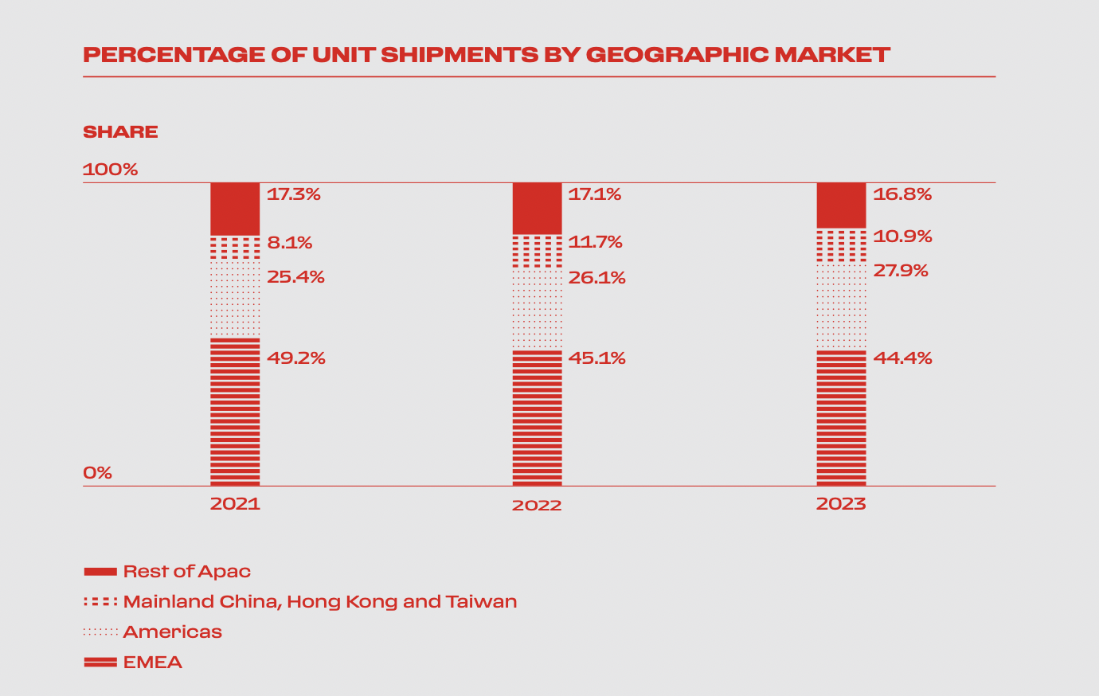

There has been a consistent **leading position of the EMEA region**, although its dominance is slightly decreasing over time. Conversely, there's a noticeable growth in the APAC markets, with the Rest of APAC showing a steady increase and Mainland China, Hong Kong, and Taiwan emerging as the second-largest market in 2023. The Americas region shows a gradual decrease in its share of unit shipments each year.

Total Shipments: In 2023, Ferrari shipped 13,663 units, marking a 3.3% increase compared to the previous year. The growth was driven primarily by the introduction of new models and increased demand in key markets.

* EMEA Region: Shipments increased by 1.8%.
* Americas: Shipments rose by 10.6%.
* Mainland China, Hong Kong, and Taiwan: Shipments decreased slightly.
* Rest of APAC: Shipments remained relatively flat.

Revenue by Segment:

* Cars and Spare Parts: Generated €5,119 million, up 18.5% from the previous year, benefiting from a richer product mix, increased personalization, and higher pricing.
* Sponsorship, Commercial, and Brand: Generated €572 million, a 14.6% increase, driven by new sponsorships, higher Formula 1 revenues, and enhanced lifestyle activities.
* Engines: Generated €127 million, down 18.4%, due to the expiration of a contract with Maserati.

**COMPANY SPECIFIC POSITIVES**

* **High residual value makes Ferrari an investment.**
* Ferrari's customer loyalty program effectively enhances brand exclusivity and customer retention, crucial in maintaining strong demand. Unlike typical luxury vehicles, Ferraris often appreciate in value. A STIFEL report highlights that a used Ferrari can command prices approximately 20% higher than its original sale price, with specific hypercar models like the 1985 Ferrari 288 GTO appreciating by about 2700% over time, or roughly 9% annually.[1] Ferrari’s meticulous customer loyalty program and strict ownership prerequisites for purchasing elite models further bolster the brand's exclusivity and residual value. To be eligible to purchase a hypercar model, one needs to own several “entry-level” models and pass a background check by Ferrari, supporting Ferrari’s high residual value in the second-hand market.

**Figure 1: Used car prices as % of new car revenues per car: Aston Martins are for rich people, Ferraris are for investors**

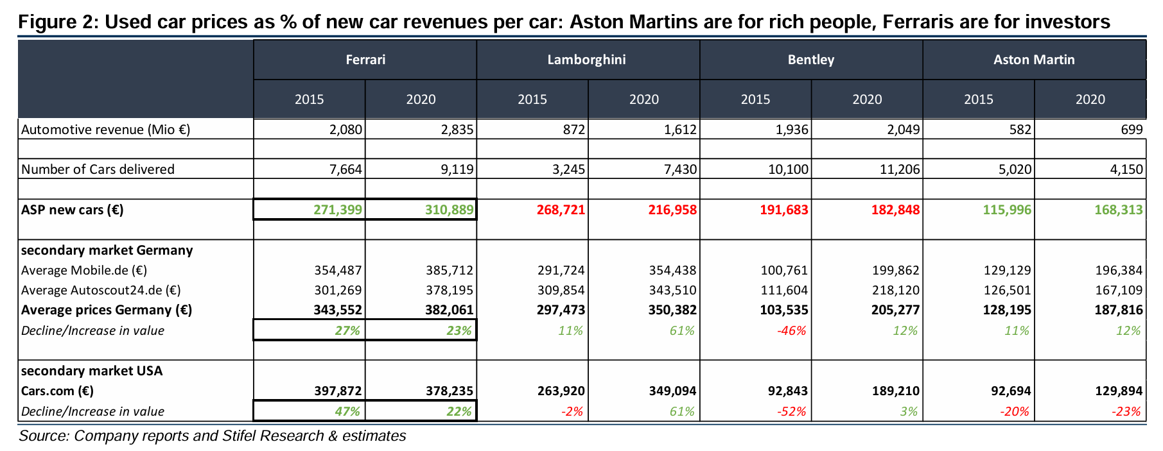

* **Ferrari has predictable and promising earnings** 
  + Ferrari consistently demonstrates robust financial health, driven by strong demand leading to sold-out models through 2026.[2] Even during economic downturns, Ferrari maintains stable sales, unlike competitors such as Aston Martin and Bentley. This demand is partially driven by high resale values, which justifies a high multiple. However, there is a concern surrounding the lower residual values of SUVs and BEVs compared to classic sports cars. From the supply side, Ferrari's focus on limited production volumes ensures that demand consistently outstrips supply. The brand's strategic production cap at its Maranello plant—13,000 units, expandable to 15,000 with additional shifts—maintains a balance between exclusivity and scalability, keeping CAPEX low and earnings predictable.[3]
* **Ferrari's enduring legacy in Formula 1 racing enhances its brand prestige and drives economic gains.** 
  + Ferrari’s enduring engagement in Formula 1 since its inception in 1950 significantly boosts the brand's distinct identity and exclusivity. This long-standing participation not only underscores their racing DNA but has also been pivotal in enhancing brand recognition and customer retention, which are vital for sustaining strong demand. The brand's consistent presence in this premier racing series enhances global recognition and contributes materially to its revenue streams—9.6% of net revenue in FY23 came from F1-related activities (sponsorship, commercial activities, and brand-related initiatives), marking a 14.6% increase from FY22.[4] This growth is largely fueled by Formula 1, where Ferrari garners revenue through team sponsorships, F1 prize money from the sport's commercial rights holder, and a unique fixed bonus awarded for their consistent participation in the racing series.
  + The growing global popularity of F1, propelled by media developments like Netflix’s 'Drive to Survive', continues to enhance Ferrari's financial gains from the sport- a 30% annual growth in media rights revenue from FY21 to FY23.[5] With the strategic acquisition of seven-time F1 world champion Lewis Hamilton for the 2025 season, Ferrari is well-positioned to leverage the media landscape, potentially increasing its sponsorship and prize money revenue significantly.
* **Prudent capital return policy.**
  + Ferrari currently distributes its FCF in a 50/50 split between dividends and buybacks (€2B for each) and the latest buyback event was from July 1, 2022, to April 12, 2024. Ferrari's balanced approach to dividend distribution and share buybacks reflects a strong capital return policy, catering to both European preferences for dividends and the U.S. investor inclination towards buybacks, thereby appealing to a global investor base.

**COMPANY SPECIFIC RISKS**

* **Challenges in the transition to Electric Vehicles(EVs).**
  + **Consumer acceptance and weaker demand risks:** Ferrari's brand is associated with high-performance sports cars characterized by their distinctive engine sounds and driving experiences—attributes that might be compromised with electric vehicles or EVs. There's concern that traditional customers may not embrace this shift, potentially affecting brand loyalty and sales. A survey revealed that 65.5% of high-end sports car owners are unlikely to consider an electric sports car, with only 10% willing to pay a premium for an electric model over an ICE vehicle.[6] The risk of weaker demand for electric Ferraris compared to traditional internal combustion engine (ICE) models could affect Ferrari's pricing power and future revenue streams as the automotive industry shifts towards electric vehicles.

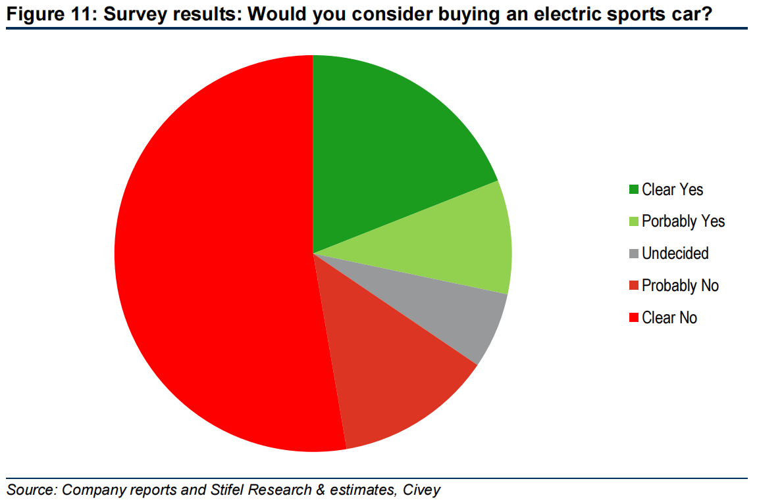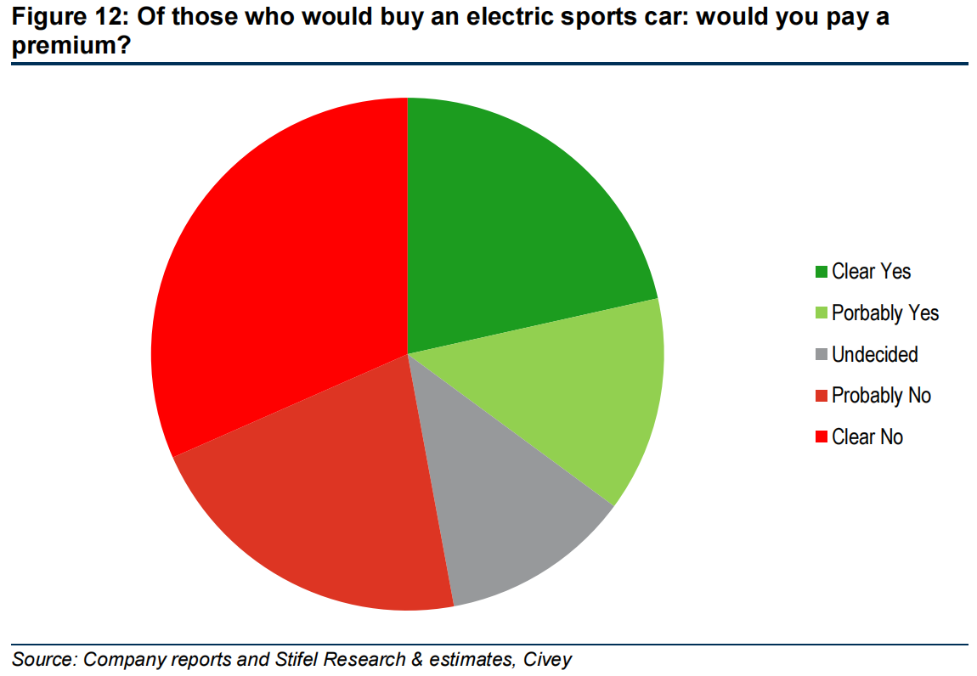

* + **Residual Value Concerns:** The transition to EVs risks Ferrari’s traditionally high residual values. EVs typically depreciate faster than ICE vehicles due to concerns about battery longevity and replacement costs. Additionally, rapid advancements in EV technology could make older models obsolete more quickly, potentially undermining Ferrari's reputation for enduring value in the luxury vehicle market where vehicles are often viewed as investments.
* **Regulatory risks related to emissions standards.**
  + Ferrari faces significant regulatory risks related to emissions standards, particularly in key markets such as the United States, the European Union, and China. Ferrari's compliance with U.S. regulations, notably those enforced by the California Air Resources Board (CARB) and the Environmental Protection Agency (EPA), is crucial. California has set stringent greenhouse gas emissions standards, which Ferrari must meet independently even if they align with federal standards. Furthermore in Europe, the “Fit for 55” package aims for substantial CO2 reductions by 2030, presenting further compliance hurdles.[7]
* **Overproduction and dilution of exclusivity.**
  + Ferrari's limited supply has been crucial in maintaining its brand's exclusivity and luxury status. However, since 2014, Ferrari has increased its unit sales at a significantly faster rate compared to prior years, raising concerns about potential brand dilution. This rapid increase in sales volume was partly driven by the company's introduction of new models and strategies to boost profitability. Maintaining this balance is essential, as overproduction could compromise the exclusivity that Ferrari's clientele values. The company must navigate these challenges carefully to ensure that it meets demand without undermining its prestigious image.[8]

**RETURNS ON CAPITAL & CAPITAL ALLOCATION**

* + ROIC History: The ROIC has been consistently increasing from 2012 to 2023. This can be attributed to the increase in capital expenditures (CAPEX) initiated in 2019, focused on design, development, and production enhancements.
  + The recent establishment of a 40,000 square-meter e-building facility in Maranello, Italy, signifies Ferrari's commitment to laying a solid production foundation for Battery Electric Vehicles (BEVs). This strategic move is expected to bolster Ferrari’s ROIC further as it adapts to evolving market demands in the automotive industry.[9]

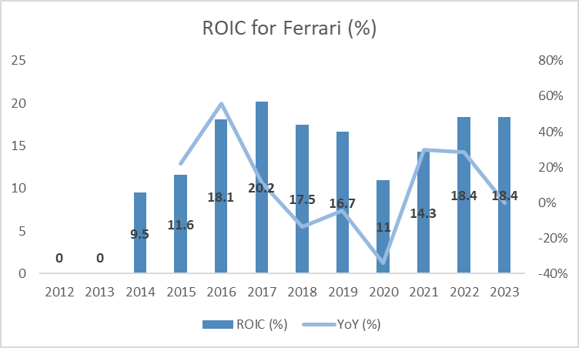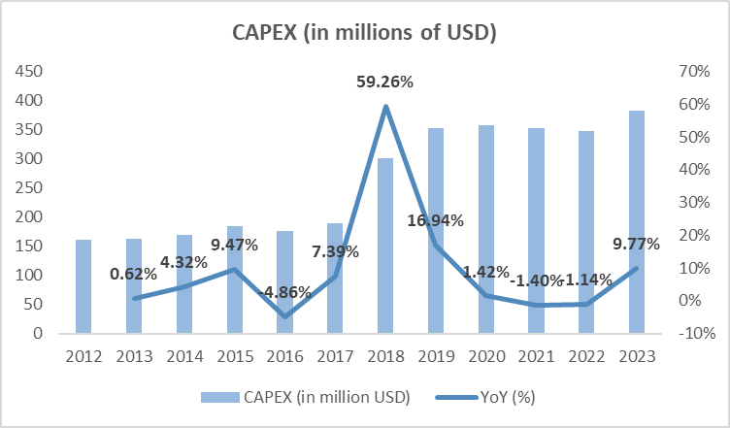

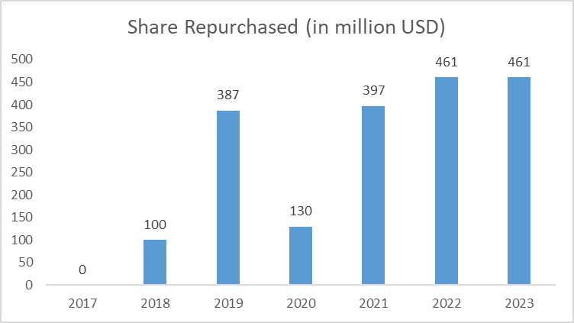

* Historical Capital Allocation:
  + Over the years, one of the major drivers for the increase in ROIC has been increased Capex, which is attributable to the increased purchase of property and technological enhancements for the expansion and production of BEVs. The average Capex over the past 5 years has been $575 million, which shows that the increased Capex has helped improve the Operating profits before tax (EBIT). The returns on these investments have consistently outstripped the cost of capital, justifying Ferrari's strategic allocation towards expansion and technological acquisition.
  + Another area of capital allocation has been the increase in share repurchases and the distribution of common dividends. This impacts the ROIC in two significant ways. Firstly, share repurchases decrease the total invested capital, which enhances the ROIC ratio. Secondly, as a result of the reduced number of outstanding shares from these repurchases, dividend distributions effectively increase. Additionally, with substantial investments in infrastructure and development, the Earnings Per Share (EPS) rise, leading to an increase in stock prices. The heightened dividend payouts suggest stable operations and a shift away from reliance on debt for financing growth.
  + Between 2020 and 2021, Ferrari's ROIC rose even with stable Capex, driven by revenue growth from high-margin products, enhanced asset utilization, strategic capital allocations such as share buybacks, and gains from previous technological advancements. Ferrari's strong brand ensured high pricing power and customer loyalty, while deferred Capex projects due to the pandemic contributed to sustained high returns.

**Does it fit our criteria?**

* **Market Leadership** – Ferrari is a market leader in the luxury performance car industry.
  + **Competitors** – Key competitors include:
    - Lamborghini: Owned by Volkswagen Group, with a market cap of $69.71 billion and an EBIT margin of 7.6%.
    - McLaren: Known for cutting-edge technology, yet with a smaller market cap of $261.37 million.
    - Aston Martin: Combines luxury and performance with a market cap of $1.56 billion.
    - Rolls-Royce and Bentley: Represent the apex of luxury with respective market caps of $42.42 billion and $17.25 billion.
    - Hermes and Rolex: Both serve the broader luxury market, with market caps of $258.18 billion and $602 million respectively, competing with Ferrari in terms of lifestyle and luxury status.
* **History of Profitability** – Ferrari has generated positive FCF and NI through recessions such as the pandemic (2020). Despite an 8% revenue decline in 2020, profitability was sustained, and a substantial 23% revenue increase followed in 2021. From the beginning of COVID to the end of 2023, Ferrari increased revenues by over 58%, highlighting its robust profitability.
* **Strong Balance Sheet** - Ferrari maintains a strong balance sheet, with the current assets to current liabilities ratio averaging above 3.99 from 2021 to 2023, showcasing financial stability and conservative leverage. For comparison, Aston Martin, a direct competitor of Ferrari, had a ratio of 1.08 in 2022[10].
* **Quality Mgmt** – The leadership has seen changes post-2014, marking a shift towards a more conservative financial strategy under CEO Benedetto Vigna, who focuses on preserving the Ferrari brand’s prestige rather than expanding through acquisitions.[11] Until 2014, Ferrari was run by Luca Cordero di Montezemolo for 23 years when he resigned. The CEO was replaced several times in the following decade, showing less stability in the C-Suite. This gives a possible explanation for the increase in long-term investments beginning in 2016, showing a possible change in financial strategy and greater risk-aversion.[12]
* **Hamilton Helmer’s 7 Powers –**
  + ***Scale economies:*** N/A
  + ***Network economies:*** N/A
  + ***Counter-positioning:*** N/A
  + ***Switching costs:*** High, with emotional and status-based costs due to strong brand loyalty, club memberships, and customer experiences.
  + ***Branding:*** Strongest power for Ferrari; the brand is synonymous with luxury, performance, and prestige, which justifies premium pricing and creates a loyal customer base less sensitive to price.
  + ***Cornered resource:*** N/A
  + ***Process power:*** High, as Ferrari effectively manages limited production to enhance profitability with minimal operational cost increases.

Valuation

**Management guidance:**

Ferrari's management has provided optimistic guidance for 2024, driven by:

* Strong product mix and personalizations, expected to drive revenue growth of at least 7% to €6.4 billion or higher
* Robust brand investments, aimed at maintaining premium positioning, with a planned increase of 10% in brand expenses
* Efficient cost management, despite persistent inflationary pressures, with a target of maintaining a flat operating expense ratio
* Significant investments in hybrid and electric vehicles, aligning with industry trends, with a goal of hybrid models constituting nearly half of total shipments

Management expects adjusted EBIT and EBITDA margins to remain strong, at 27% and 38%, respectively, despite increased capital expenditures of €700-750 million and higher tax payments, leading to adjusted diluted EPS growth of at least 9%.[13]

## Assumptions:

|  | Base | Downside | Upside |
| --- | --- | --- | --- |
| Revenue | **2024:** Expect a drop in revenue growth compared with post-Covid numbers, due to slower adoption of new electric vehicles and ongoing economic and regulatory pressures.  **2025/2026:** Expect an increase in market acceptance of new models/technologies. | **2024:** Expect a larger drop in revenue growth due to the depreciation in electric vehicles discouraging sales and ongoing economic and regulatory pressures. **2025/2026:** Remain the same growth rate as 2024 due to lack of market acceptance of new models/technologies. | **2024**: Expect a robust 10% revenue growth rate due to successful penetration in new markets and product lines (BEVs and SUVs). **2025/2026**: Growth accelerates to 11% due to continued acceptance of new models, expansion into new markets, and increased personalization options. |
| EBITDA Margin | **2024:** 33%, reflecting initial gains from recent strategic shifts, including model lineup expansion and a push towards EV. **2025/2026:** Balances benefits from previous investments with rising costs of new strategies. | **2024**: 31%, reflecting increasing cost in promoting the new model lineup. **2025/2026:** 32%, balances benefits from previous investments with rising costs of new strategies. | **2024**: 35%, benefiting from initial gains from strategic shifts towards high-margin EVs and personalization options, as well as efficient cost management practices. **2025/2026:** 37%, maintaining the benefits from previous investments in new technologies and models with ongoing operational efficiencies and premium pricing strategies |
| Owner Earnings multiple | Used our model's growth rate. | Used our model's growth rate. | Used our model's growth rate. |

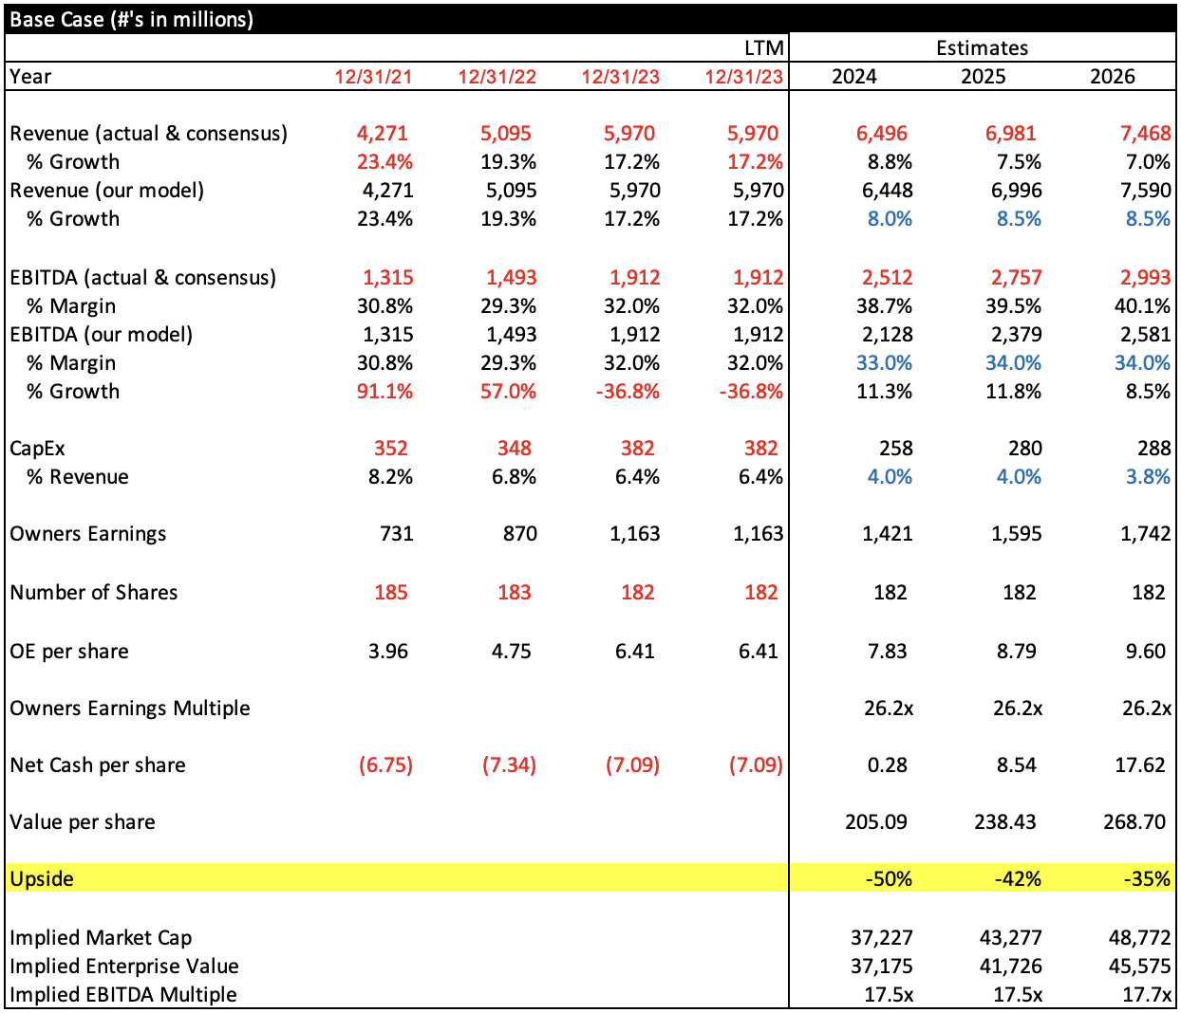

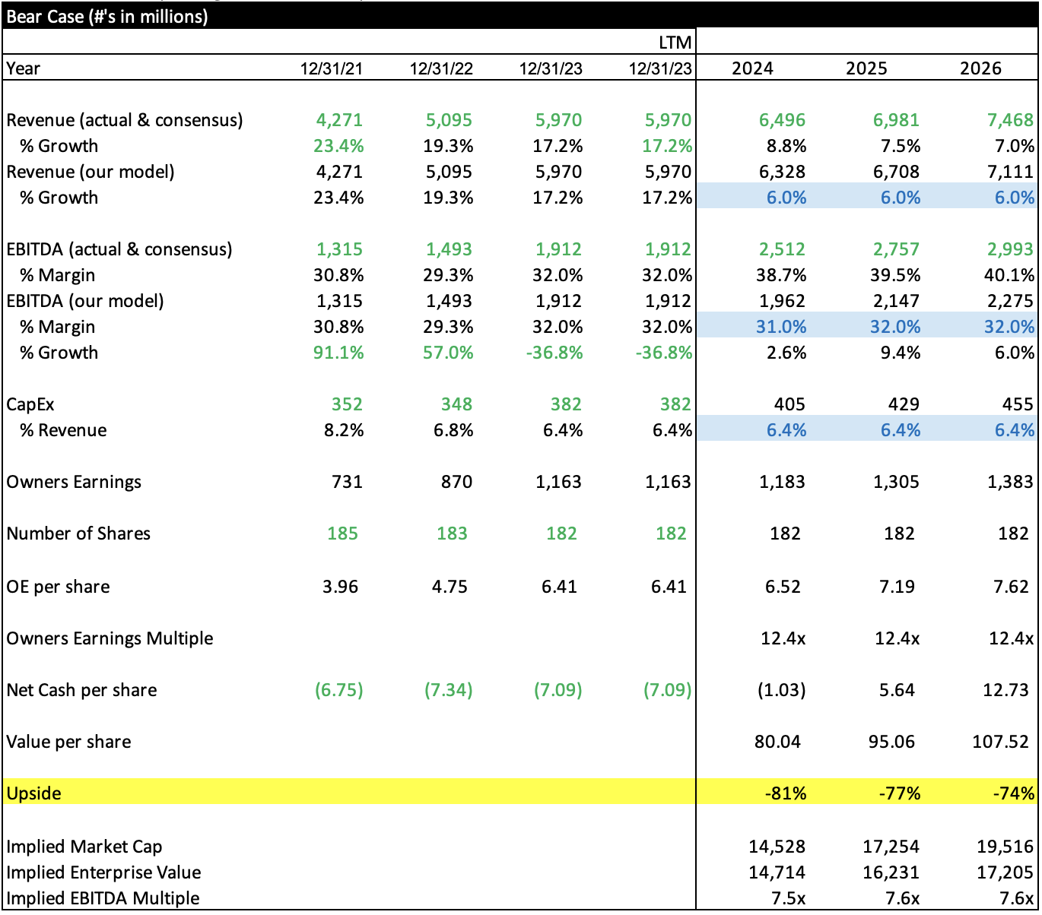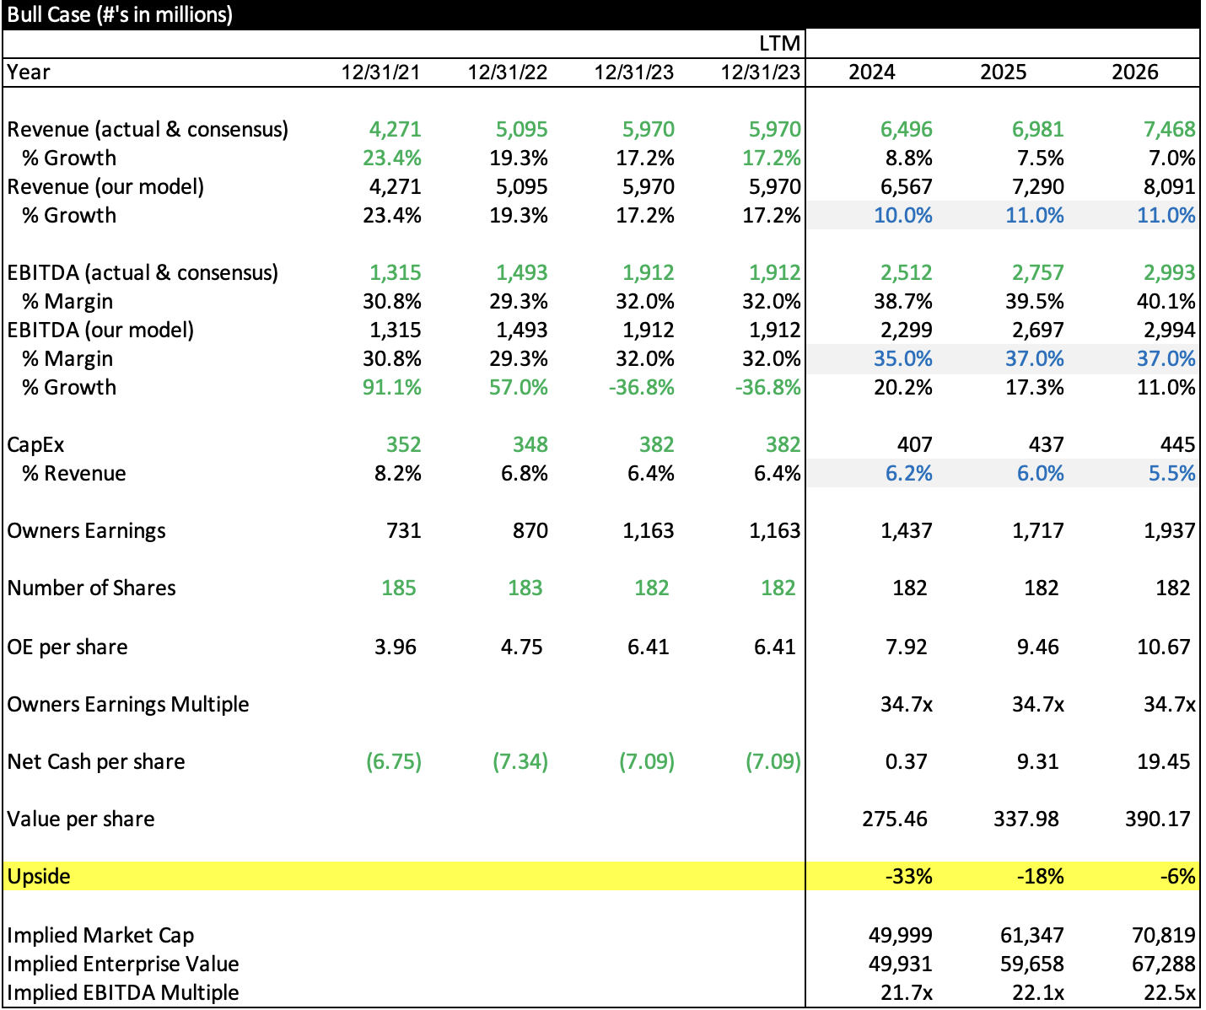

Appendix:

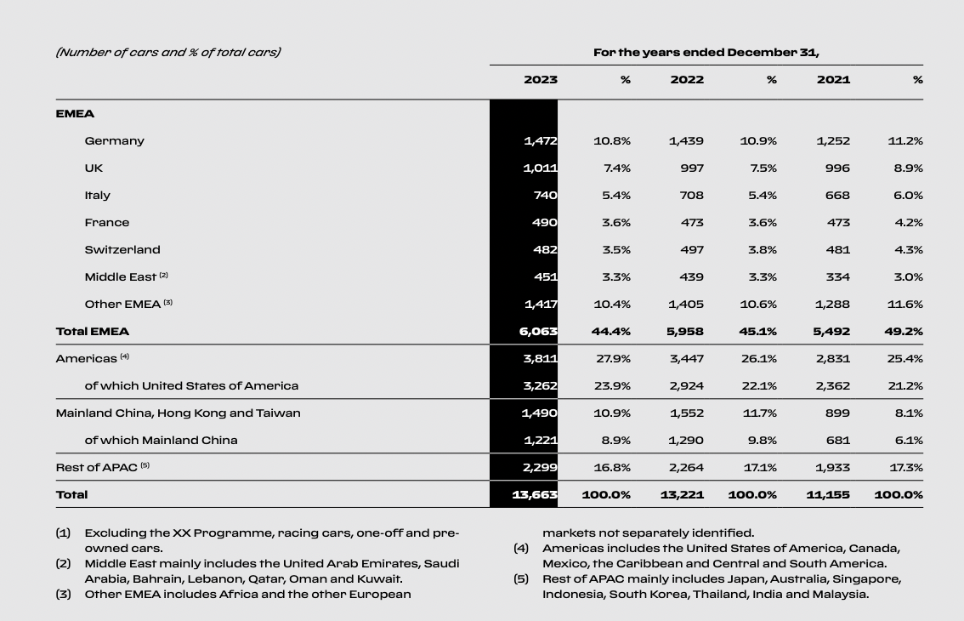

1. 2024-01-29 Stifel Equity Research
2. 2024-01-29 Stifel Equity Research
3. 2024-03-25 RBC Equity Research
4. 2024-02-22 [Ferrari Annual Report 2023](https://cdn.ferrari.com/cms/network/media/pdf/Ferrari-2023-annual-report-april-17-2024.pdf?_gl=1*mkeod3*_ga*MTQ4MTk4MjI3OS4xNzEyMDY2Nzky*_ga_JM1HT9B412*MTcxNDE2Mzg3Ny41LjAuMTcxNDE2Mzg3Ny4wLjAuMA)
5. 2024-02-28 [Liberty Media Annual Report 2023](https://d1io3yog0oux5.cloudfront.net/_8267aa28a39e29a061d0b31e5b8fc787/libertymedia/db/2054/20081/annual_report/Liberty+Media+Corporation+Proxy+Statement+-+Annual+Report+-+Bookmarked.pdf)
6. 2024-01-29 Stifel Equity Research
7. [Ferrari Annual Report 2023](https://cdn.ferrari.com/cms/network/media/pdf/Ferrari-2023-annual-report-april-17-2024.pdf?_gl=1*mkeod3*_ga*MTQ4MTk4MjI3OS4xNzEyMDY2Nzky*_ga_JM1HT9B412*MTcxNDE2Mzg3Ny41LjAuMTcxNDE2Mzg3Ny4wLjAuMA)
8. https://www.roadandtrack.com/new-cars/news/a8667/ferrari-ceo-rage-quits-calls-the-brand-american/
9. Ferrari Annual Report 2023
10. [Aston Martin Annual Report 2022](https://www.astonmartin.com/-/media/corporate/documents/annual-reports/aston_martin_annual_report_2022.pdf?rev=6a462584d1c54890a85a324a2663c3d7&hash=9A3C425CE6101D99D4249E882AA19A4F)
11. [https://www.reuters.com/business/autos-transportation/ferrari-does-not-need-buy-other-supercar-makers](https://www.reuters.com/business/autos-transportation/ferrari-does-not-need-buy-other-supercar-makers-ceo-says-2023-06-05/)
12. <https://ferriscars.com/tag/ferrari-ceo/>
13. Ferrari FY 2023 Results Press Release